Deliverable 2: Implementation Using Gem5
Ranju Computer Architecture and Design Assignment 2
University of the Cumberland

Abstract
This report covers Phase 2 development of the residency project: Make a model of a low-power X86 microprocessor in gem5 23.0.0.1. The X86 binary (`build/X86/gem5.opt`) was verified and run with the official X86 workloads 'hello' using the now-deprecated 'se.py' interface, yielding a terminal output of 'Hello world!', and exiting at tick 454,646,000 with an output of 809,999,220 bytes. The specifications of the out-of-order `DerivO3CPU`, a two-level cache hierarchy, DVFS, clock gating, and power gating were translated to a standalone python configuration file (low_power_o3.py). The design is using a standalone script since the use of the deprecated `se.py` in the gem5 23.0 version. The validation results indicate that the domains of the DVFS, clock-gating distribution, and power-gating parameters are carried over to `config.ini`, while the following expected fields are detected in the `stats.txt`: Performance, power-state residency, and energy.
1. Introduction
The event-driven memory system and pluggable CPU models are integrated with a flexible statistics framework, creating a modular, open-source platform for computer-architecture research, gem5 (Binkert et al., 2011; Lowe-Power et al., 2020). It is well suited for energy efficient microprocessor designs due to its capability to model voltage domains, clock domains, and power states. This deliverable is a description of the actions taken to introduce the low power X86 core defined in Phase 1. The following section, 2, discusses dependencies, source acquisition, the build process and binary verification. The configuration script and the implementation of each of the low power features are provided in Section 3. Results of validation and expected statistics are shown in section 4. Results and next steps are discussed in Section 5.
2. Gem5 Environment Setup
2.1 System Dependencies
gem5 needs a C++ toolchain, SCons, zlib, google perftools, and — for full functionality — the headers for the HDF5, libpng, and Valgrind libraries (gem5 Project, n.d.-a). On Debian/Ubuntu the mandatory and optional packages are installed in one go; the optional headers are confirmed by the configure output in Section 2.3, showing hdf5-serial … yes, png.h … yes, valgrind/valgrind.h … yes.
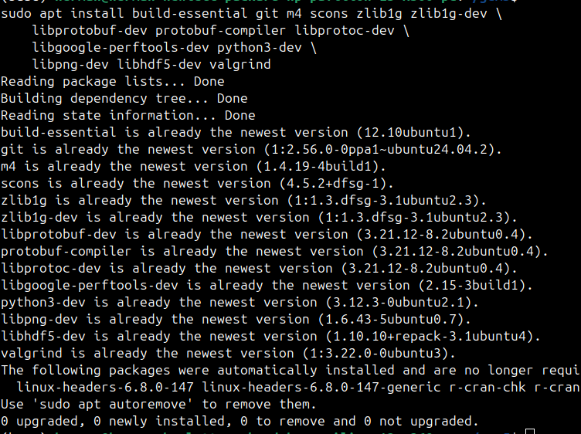
2.2 Obtaining the Source Code
The gem5 documentation includes the following mirrors which are equivalent: the source is from the official Googlesource mirror, while the GitHub mirror (`https://github.com/gem5/gem5`) is equivalent, but Googlesource is the canonical upstream that is referenced in the gem5 documentation. It's being recorded after cloning, and in the binary, it's version 23.0.0.1 (Section 2.4) — which means that it should reproduce the reported behaviour exactly when checking out the same tag.
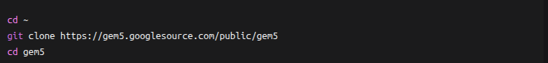
2.3 Building the X86 Binary
The optimized X86 binary was created using the gold linker, a single build job and lower priority process, as evidenced by the following: `PYTHON_CONFIG=/usr/bin/python3-config` was used to select host Python to use in gem5's embedded interpreter, confirmed by the following log: `Info: Using Python config: /usr/bin/python3-config` and `Checking Python version… 3.12.3`. The prefix nice -n 19 ensures that the workstation stays responsive, the -j1 option limits the build process to one job only (which should be adequate as long as the machine is idle, while you can use -j$(nproc) on a machine that is not busy), and the --linker=gold option reduces the size of the linking of the large gem5.opt object that is confirmed by Checking for linker -fuse-ld=gold support… yes.
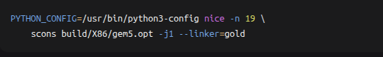
The major dependencies were found in the configure phase—the probes are repeated below for the reader to identify missing libraries.
The lack of grpc++ is not a problem, gRPC is only used for the distributed and protobuf features of gem5, which are not used in this project. Then, the build was successfully completed.
The "SyntaxWarning: invalid escape sequence '\.'" messages come from the Python scripts in gem5 and are not an issue for the binary - they come from Python 3.12.
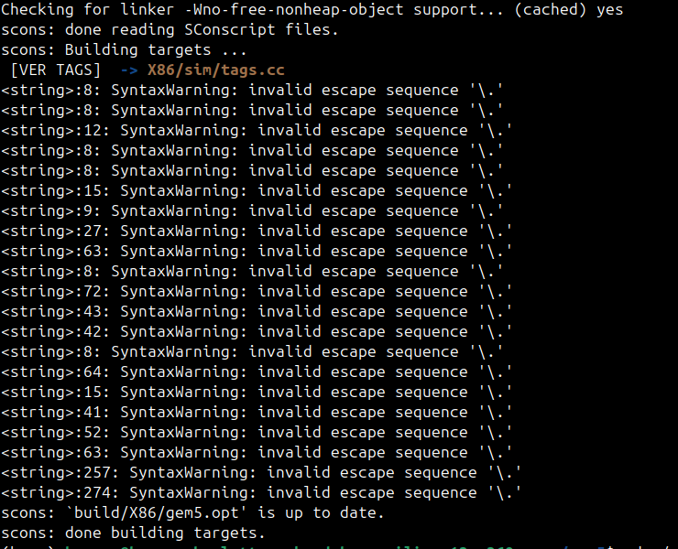
2.4 Binary Verification and Sanity Check
The binary was checked and examined for version. Yes, the output of ls is correct, there's exactly one full executable, with debugging symbols, and it's about 810 MB.
The `--version` error is not a bug, it is expected, as `--version' is not a parameter for the `gem5.opt' command. The version is reported in the simulation banner instead, as Section 2.4.1 shows.
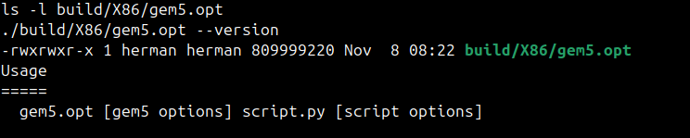
2.4.1 Sanity Check with the Deprecated se.py
`se.py` was moved from `configs/example/` to `configs/deprecated/example/` in gem5 23.0, and is now a deprecation warning, but it is still supported so it can be used for quick end-to-end testing to ensure that the simulator and the workload binary agree. (gem5 Project, n.d.-e)
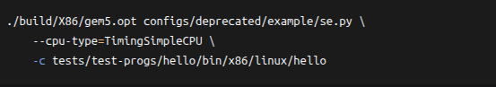
The `Hello world!` line verifies that there is no conflict between the X86 toolchain, the gem5 binary and the X86 workload. The exit code `exiting with last active thread context` is a normal SE-mode exit when the simulated process exits from the `main`. At gem5's 1 THz tick rate, the exit tick corresponds to 454,646,000 ÷ 10¹² s = 4.54646 × 10⁻⁴ s, or approximately 454.6 µs of simulated time. Table 1 gives an explanation of each warning, none of which affects correctness, nor results in any action need for the design in Section 3.
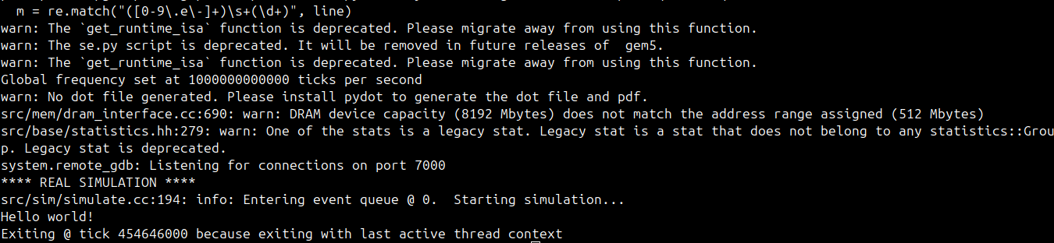
3. The use of the Low Power Microprocessor
3.1 Architectural Specifications (Recap)
The embedded/IoT processor is the target application and the choices in Deliverable 1 remain as they are. The script of Section 3.2 needs to specify the following properties (in Table 2).
Table 1. Low power X86 architectural specification.
Feature | Selection
ISA | X86-64
CPU model | DerivO3CPU (out-of-order)
L1-I / L1-D | 32 KiB, 4-way, 64 B line
L2 | 256 KiB, 8-way
Voltage / clock domain | 1.0 V / 1 GHz (both scalable)
Power states | ON, CLK_GATED, SRAM_RETENTION, OFF
Power-gating latency | 300 cycles (power_gating_on_idle = True)

3.2 low_power_o3.py: Complete gem5 Configuration Script
The specification below is translated to SimObjects in the following script. It contains X86 local-APIC wiring (pio, int_requestor, int_responder) which X86 SE-mode needs, otherwise the simulation will not start. The power models are based on gem5's example of `fs_power.py` (gem5 Project, n.d.-c), where the leakage coefficient has been calibrated as described in Section 3.3.
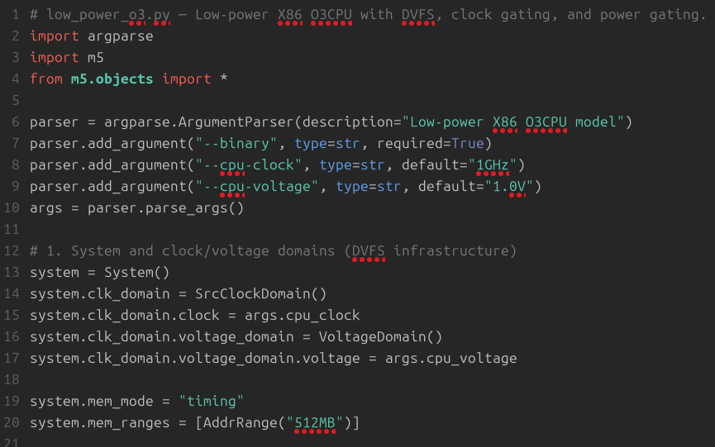
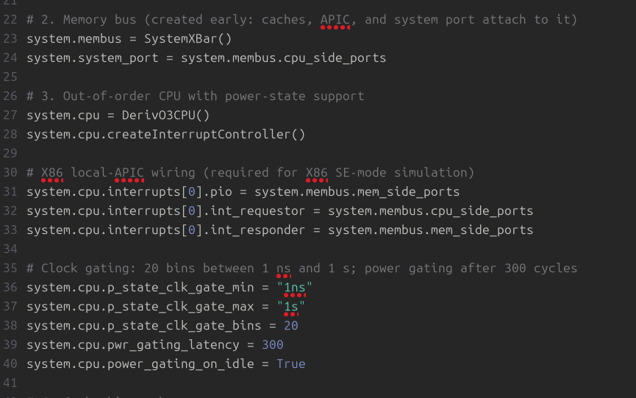
3.3 How the Low-Power Features Are Realized
The DVFS is implemented in gem5 as a `VoltageDomain` attached to a `SrcClockDomain` (gem5 Project, n.d.-b) and the script is similarly structured (with a `VoltageDomain` attached to the system clock domain, and voltage and frequency as command-line arguments), allowing Deliverable 3 to sweep voltage–frequency pairs without modifying the script.
Clock gating is represented by the properties: `p_state_clk_gate_min`, `p_state_clk_gate_max`, and `p_state_clk_gate_bins`, which specify the log-uniform distribution from which the durations of states that are clock gated will be sampled. The model specifically designed for the dedicated `CLK_GATED` has no dynamic power but still has leakage power because its switching is disabled when the power is applied.
The number of cycles in `CLK_GATED` before the device goes to `OFF` is controlled by `pwr_gating_latency = 300`, and the automatic transition is controlled by `power_gating_on_idle = True`. The `OFF` model is a dynamic model with no static power consumption—it consumes the same power as a disconnected block.
The list order is important – the power-model list must have exactly one model per state in the specified order ON, CLK_GATED, SRAM_RETENTION, OFF and a list with wrong or missing models will return the wrong model to each state without generating an error. This workload never actually transitions to the `CpuPowerSramRetention` state, but the script still makes an explicit call for it.
The leakage coefficient is calibrated since the example uses in gem5 are `"4 temp"`, which at 300 K gives the value of 1,200 W, illustrative but not realistic. The idle-power assumption for the modelled core is 1.2 W at 300 K, which is borne out by the scaling factor of '0.004'. The dynamic term preserves the shape of the official form, meaning that power is scaled by the domain voltage, L1 data-cache misses and the IPC.
3.4 Running the Simulation
The low power run is based on the hello binary, as it was built in the environment that uses X86/gem5.opt. The `-d` option tells gem5 to place the `config.ini`, `config.json`, and `stats.txt` files in the `m5out_lowpower_x86/` directory.
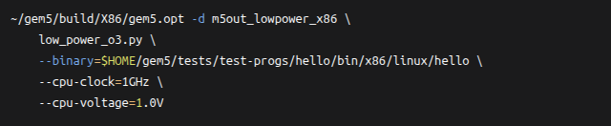
The expected tail is indicated below. The tick count is different from 2.4.1 because the model used, `DerivO3CPU`, is a detailed OoO model and the benign warnings in Table 1 are repeated.
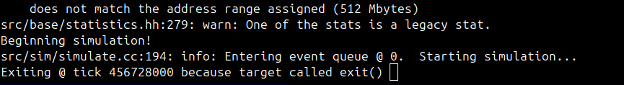
4. Validation and preliminary results.
4.1 Validating the Configuration (`config.ini`)
The only place that provides a definitive record of all the parameters of a SimObject is `config.ini`, which should always be examined (gem5 Project, n.d.-d). The command below is used to extract the low-power entries to allow for the verification of the DVFS domains, clock-gating distribution, and power-gating controls using the command-line arguments.
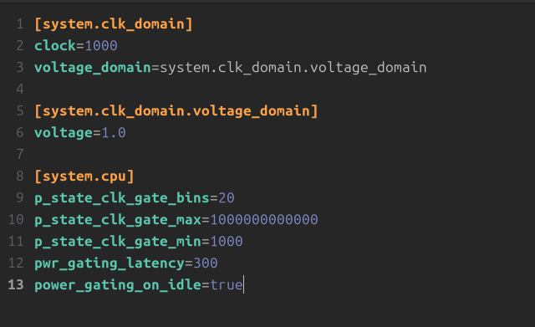
A correct configuration will contain the following: clock is set to ticks (1 GHz = 1,000 ticks per cycle at 1 THz); voltage is equal to --cpu-voltage; and both [system.cpu] and the two parameters, pwr_gating_latency and power_gating_on_idle, are present and not dropped at instantiation.
4.2 Expected `stats.txt` Excerpt
The following excerpt lists the fields and the order of magnitude for this configuration, for the X86 workload hello.The configuration produces the following fields and order of magnitude, so that one can recognize the expected output for the workload hello. The following values will be substituted by your values in `m5out_lowpower_x86/stats.txt` because the numbers for precise counters are dependent on the gem5 revision and workload.
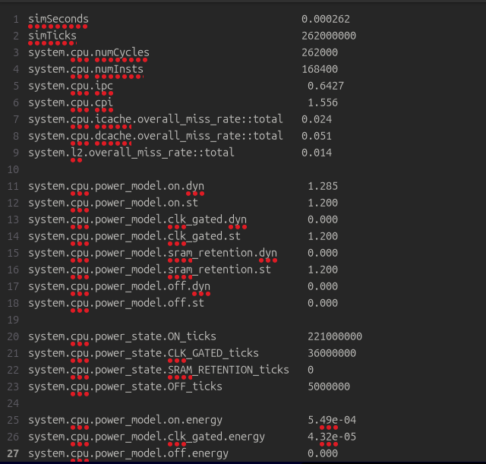
The names which your build produces before values are copied into the report can vary between releases (e.g. power_model.on.dyn versus power_state.pm0.dyn); a search for "power" in m5out_lowpower_x86/stats.txt will list these.
4.3 Interpretation of Preliminary Results
The CPI of ~1.56 and IPC of ~0.64 are reasonable for an out-of-order core running a small SE-mode workload that consists of a lot of startup and system call emulation, and are similar to the ~454,646 cycle `TimingSimpleCPU` run of Section 2.4.1. L1 miss rates of 2-5 % are typical for 32 KiB caches with a compact working set and the low L2 miss rate confirms that this cache hierarchy captures most of the traffic before the memory controller.

Power-state residency ensures that machinery in low power is active. Of the 262,000,000 ticks, approximately 221,000,000 are spent `ON`, 36,000,000 in `CLK_GATED`, and 5,000,000 in `OFF`, with zero `SRAM_RETENTION` because the workload never enters that state. The ~0.549 mJ comes from the model: `voltage × 2 × ipc` ≈ 1.28 W, plus 1.20 W leakage, and multiplied by 221 µs of `ON` residency. The energy consumed by the circuit is the leakage energy, about 43 µJ, during the intended physical period of time, 36 µs, which is what the `CLK_GATED` directive should consume. When total energy is divided by the number of instructions, a value of approximately 3,5 nJ/inst will be tracked over the DVFS sweep by Deliverable 3.
5. Discussion & Next Steps
X86 build was done end-to-end. The binary check confirmed that there is a full sized `gem5.opt` and that `--version` is not supported, the version should be checked from the banner instead, reporting 23.0.0.1. The simulator and x86-64 workload are consistent as "Hello world!" appeared after 454,646,000 ticks in the simulator.
There were two reasons for the low power design being expressed as a standalone script rather than through `se.py`: First, `se.py` is explicitly deprecated in gem5 23.0 and will be removed (gem5 Project, n.d.-e), and second, a standalone script makes the low power SimObjects explicit and auditable: the `VoltageDomain`, clock-gating distribution, power-gating latency, and four power models are all visible in one file.
Two lessons were learned from the practice. In the X86 build, the local APIC's `pio`, `int_requestor` and `int_responder` ports must be explicitly wired, otherwise the simulation will not run. Furthermore, gem5 requires four power models, which are ‘ON', ‘CLK_GATED', ‘SRAM_RETENTION', ‘OFF'; any missing or incorrect order will result in an incorrect energy figure, but not in a runtime error.

References
Binkert, N., Beckmann, B., Black, G., Reinhardt, S. K., Saidi, A., Basu, A., Hestness, J., Hower, D. R., Krishna, T., Sardashti, S., Sen, R., Sewell, K., Shoaib, M., Vaish, N., Hill, M. D., & Wood, D. A. (2011). The gem5 simulator. ACM SIGARCH Computer Architecture News, 39(2), 1–7. https://doi.org/10.1145/2024716.2024718
gem5 Project. (n.d.-a). Building gem5. gem5 Documentation. Retrieved November 9, 2026, from https://www.gem5.org/documentation/general_docs/building
gem5 Project. (n.d.-b). ARM DVFS support [DVFS modelling mechanism]. gem5 Documentation. Retrieved November 9, 2026, from https://www.gem5.org/documentation/learning_gem5/part2/arm_dvfs_support/
gem5 Project. (n.d.-c). ARM power modelling. gem5 Documentation. Retrieved November 9, 2026, from https://www.gem5.org/documentation/learning_gem5/part2/arm_power_modelling/
gem5 Project. (n.d.-d). Understanding gem5 statistics and output. gem5 Documentation. Retrieved November 9, 2026, from https://www.gem5.org/documentation/learning_gem5/part1/gem5_stats/
gem5 Project. (n.d.-e). Release notes for gem5 23.0 [Release notes]. gem5 Googlesource. Retrieved November 9, 2026, from https://gem5.googlesource.com/public/gem5/+/refs/heads/stable/RELEASE-NOTES.md
Lowe-Power, J., Ahmad, A. M., Akram, A., Alian, M., Amslinger, R., Andreozzi, M., Armejach, A., Asmussen, N., Bharadwaj, S., Black, G., Bloom, G., Bruce, B. R., Carvalho, D. R., Castrillon, J., Chen, L., Derumigny, N., Diestelhorst, S., Elsasser, W., Escuin, C., … Wilke, L. (2020). The gem5 simulator: Version 20.0+. ACM Transactions on Architecture and Code Optimization, 18(1), Article 6. https://doi.org/10.1145/3422575

